http://www.tricksguide.com/collect-ahs-logs-from-hp-gen8-server.html

How to Collect AHS log from HP Gen8 Server
Article by SiRu in the category: Server · 6 Comments
HP Gen8 Servers introduced a new feature called Active Health System or AHS. AHS is an Always-ON diagnostics tool which run on your Server and save the information in a flash memory which is embedded on server system board. AHS does not use server resources like CPU or memory, rather it works on iLO Management engine. As AHS is an Always-ON diagnostics, it will capture all the changes recorded on your server.
As AHS is an always running process, it captures all the information about your Gen8 server. When you contact HP support team regarding your Gen8 server related issues, this log file will be very useful. Whenever you experience issues with your Gen8 server, I would recommend you to share the AHS log with HP support team.
In this article, we will discuss how to collect AHS log from your server. There are three methods to collect AHS logs. They are:
- Collect AHS log using HP Intelligent Provisioning.
- Collect AHS log using HP Integrated Lights Out 4 (iLO 4).
- Collect AHS log from Windows/Linux using Command line tool.
Let’s begin

Method 1: Collect AHS log using Intelligent Provisioning:
1. Turn ON your HP Gen8 server.
2. Once HP Logo screen is shown, press F10 key to launch Intelligent Provisioning.
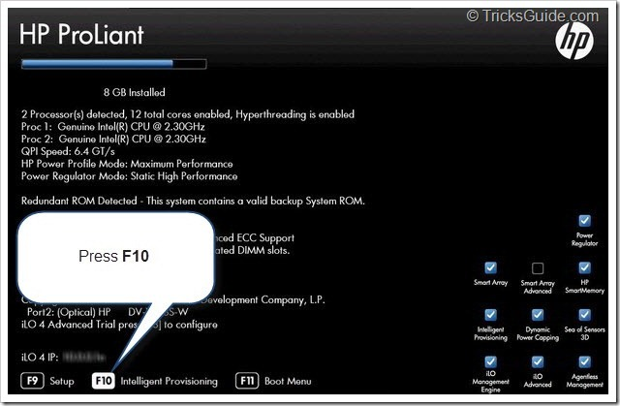
3. HP Intelligent provisioning will load on your server.

Note: If you do not see the F10 prompt at the Server POST, then please enable the F10 prompt at RBSU of you HP Gen8 Server. The steps to enable F10 prompt is explained in below provided article.
Guide: Enable or Disable HP Intelligent Provisioning in HP Gen8 Server
Note: If you receive any error when you load Intelligent Provisioning on your Gen8 Server, then you may need to re-install it on your Server. The procedure to re-install Intelligent Provisioning is explained in below provided article.
Guide: Reinstall or upgrade Intelligent Provisioning on HP Gen8 Server

4. Click on Perform Maintenance option from Intelligent provisioning.
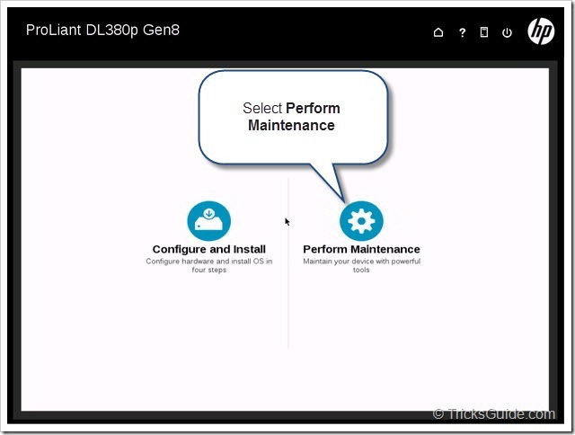
5. Now you may find a lot of utilities listed in Intelligent provisioning window.
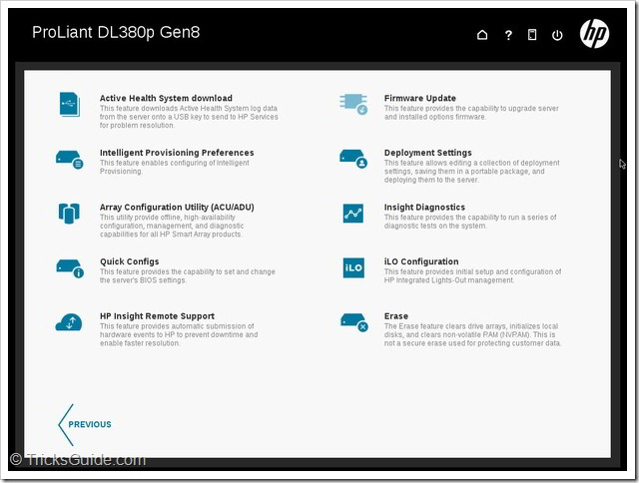
6. Click on Active Health System download as shown below.
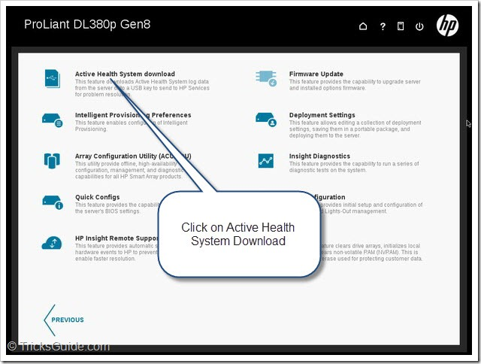
7. It will open Active Health System download window (Screenshot provided below).
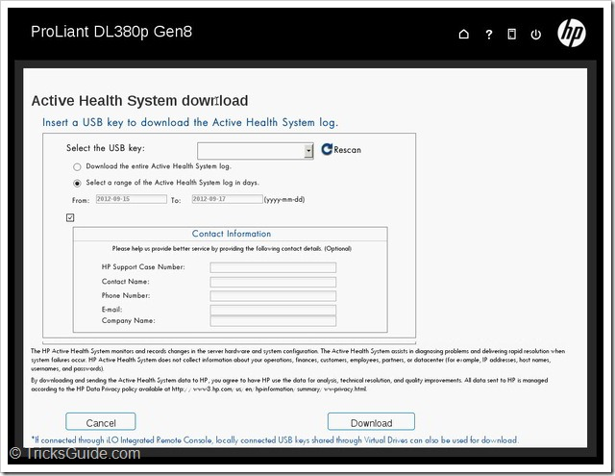
Note: You can save the AHS log file to a USB key which is directly connected to your Server. If you are in Remote location and do not have physical access to the server, then you need to use Integrated Lights-out 4 (iLO 4) of your Gen8 server and mount a USB thumb drive using Virtual media feature of iLO 4. I recommend using a USB key of size 4Gb or less. Once you have connected USB key ensure that you click on Re-scan button.
Note: If you do not have any USB thumb drive connected to the server (locally or via iLO4 Virtual media), you may receive an error message stating “No USB Keys are detected. Please insert a USB key and click the Rescan button”.
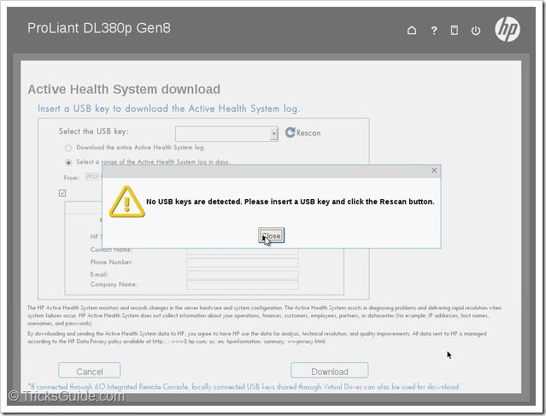8. Please connect a USB thumb drive to your Server (Local/iLO 4 Virtual Media).
Note: If you are connecting USB key physically on your server, please ignore step 9 and 10 provided below. Steps 9 and 10 is applicable only if you are in remote location and mounting a USB key using iLO 4 Virtual media.
9. To mount USB thumb drive using ILO 4, Open iLO4, Open Remote Console, Click Virtual Drives.
10. Under Floppy/USB-Key option, select the drive letter of USB key (in my case it is drive D:)
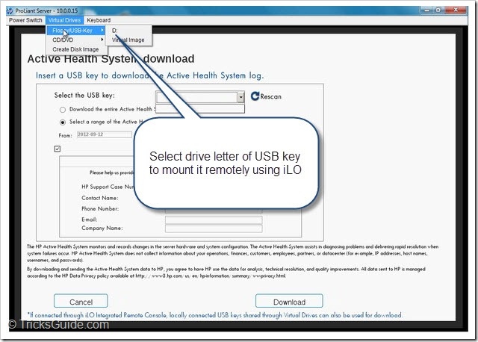
11. Click Rescan button if USB key is not detected (Check below provided screenshot).
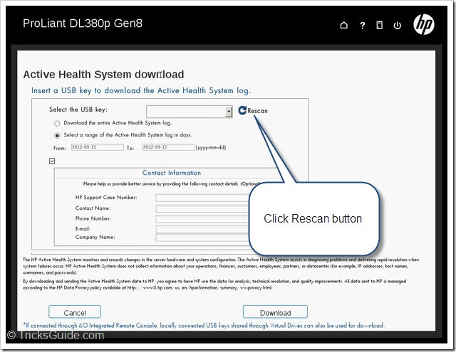
12. Now the USB drive key should be detected (Check the screenshot provided below)
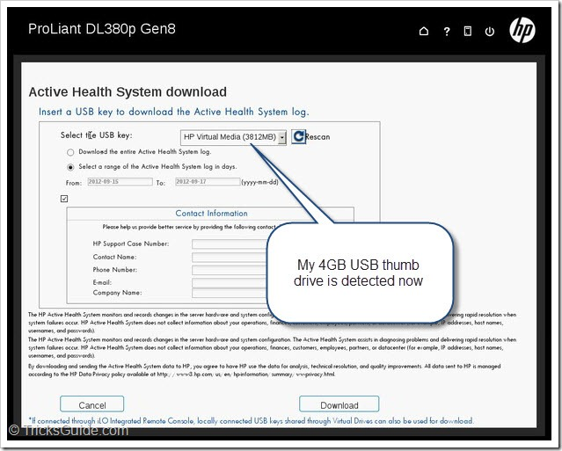Note: There are two options when you download AHS logs. First option is to download the entire AHS log. The next option is to download AHS logs between two date ranges specified. I would recommend you to download the AHS logs between specific date range.
13. Select a range of Active Health System log in days as shown below.
14. Select the start date by clicking the “From” text box.
15. Now you will see a date picker, please select a date.
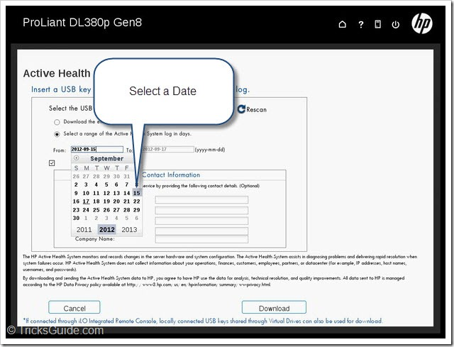
16. Click in the “To” text box, it will open a date picker as shown below.
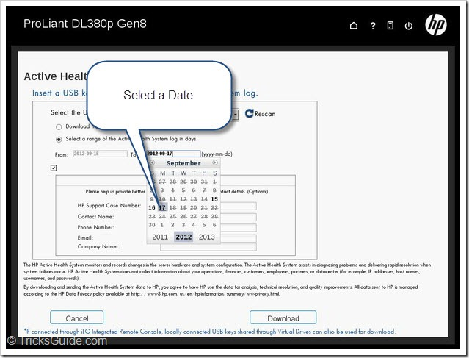
17. You may also enter Contact Information (Not mandatory, fill only if you wish).
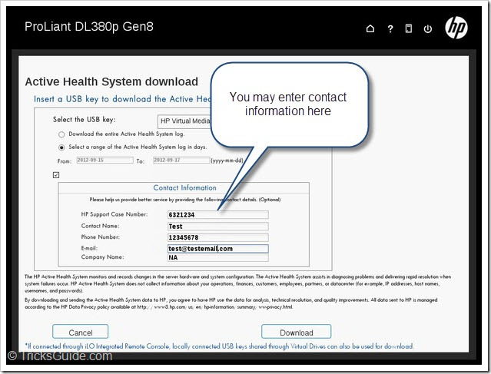
18. Click Download button to save the AHS log.
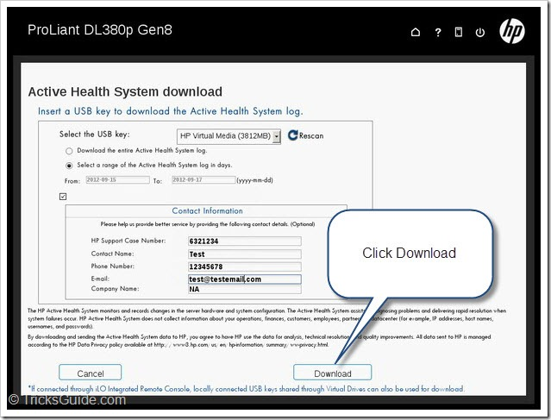
19. Please wait while AHS log file is getting saved (This may take some time).
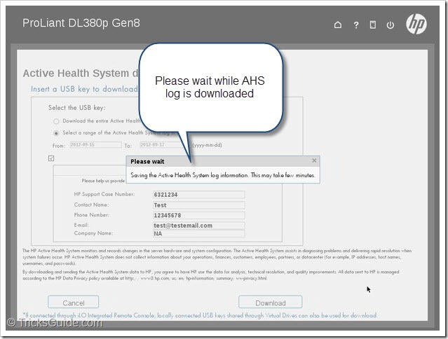
20. You will receive a window once the AHS log downloaded successfully. Click Close button to exit.
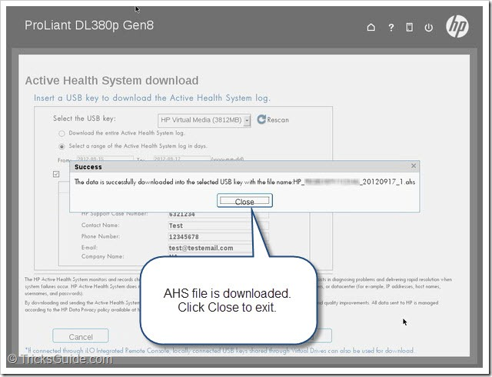

Method 2: Using Integrated Lights-out 4:
AHS log file can be downloaded directly from iLO of your HP Gen8 Server. To download the AHS log, you need to open iLO 4 web interface and there is an option available for you. Here, I will show you how to do it
1. Enter the IP address of iLO 4 at the address bar of web-browser.
2. It will open the Login screen of iLO 4 as shown below.
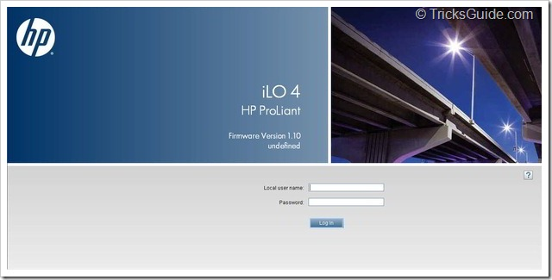
3. Once you login to iLO, click on Active Health System Log.
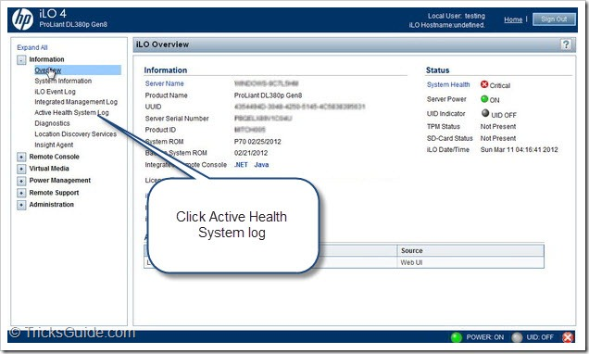
4. Now you will be at Active Health System Log page.
5. Select range of AHS log in days (Select From and To field as shown below)
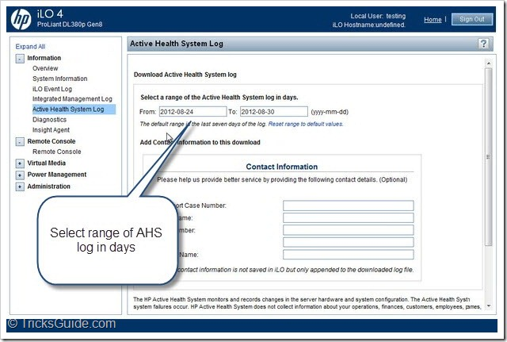
Note: The default range is set to last seven days of the AHS log. However, you can always specify the date range if you wish. I will recommend NOT to download the complete AHS log of your server as it may take lot of time.
6. Enter the Contact Information if you wish (This is Optional)
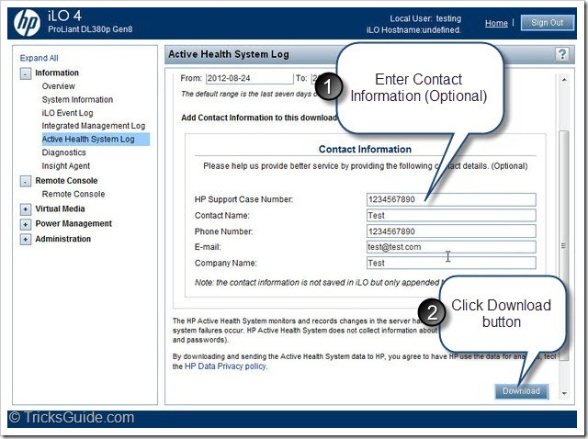
7. You will receive a Download window, Save the AHS log now.
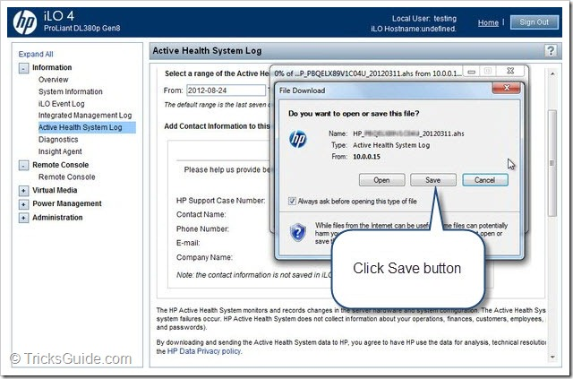
8. You may send this AHS file to HP Support team for analysis.

Method 3: Collect AHS from Windows/Linux Operating System:
HP released a command line tool (CLI) which can be run from Windows and Linux Operating System. This tool will be very useful in situation where you do not have access to ILO 4 Or you do not want to restart your server to launch Intelligent Provisioning. This CLI tool is available for both Windows and Linux and can be used to collect AHS report from the Operating system.
If you are using Windows OS on your server, then you may download the AHS Download CLI for Windows from the driver download page of your Server.
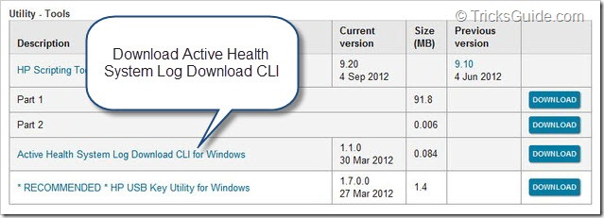
If you are using Linux operating system, then you can download the AHS Download CLI tool from the Linux OS driver download page of your Server.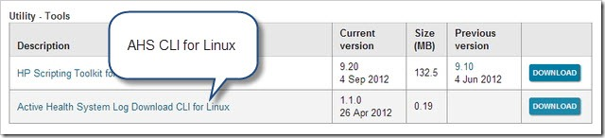
I have written an article about this command line tool. This article explains how to download, install and use command line tool on your Windows OS. I would recommend you to check my article regarding AHSdownload CLI tool provided below.
- Guide: Download AHS log of HP Gen8 server using Command Line
If you server is running Linux Operating system, then you can download the AHS CLI for Linux and use it. Remember that this tool will work only if the drivers of the iLO is loaded on your server. If no iLO drivers are installed in the operating system, then you will receive an error when you use this tool.
- See more at: http://www.tricksguide.com/collect-ahs-logs-from-hp-gen8-server.html#sthash.8PRNySJ9.dpuf

AHS report does not capture any sensitive personal data and it is completely safe to share this log files with HP support. I checked HP website and I find that AHS received TRUSTed Cloud Data Privacy Certification from TRUSTe. Thanks :) - See more at: http://www.tricksguide.com/collect-ahs-logs-from-hp-gen8-server.html#sthash.8PRNySJ9.dpuf

http://www.tricksguide.com/download-ahs-log-hp-gen8-server-active-health-system-log-cli.html

Download AHS log of HP Gen8 server using Command Line
Article by SiRu in the category: Server · 4 Comments
HP Active Health System (AHS) is a revolutionary feature introduced in HP Gen8 Servers. Active Health System collects all the hardware changes happened on server. AHS does not use any CPU cycles of your server hence it does not affect your server performance. AHS is an always running process and it does not require any drivers or agents.
AHS can be compared with Flight Recorders (Also called as Black Box) available in commercial airplanes and can be really helpful to find the reason of Airplane crash. Same way, when you share AHS log with HP support personal, it will improve the accuracy of diagnostics and will reduce the overall issue-resolution time.
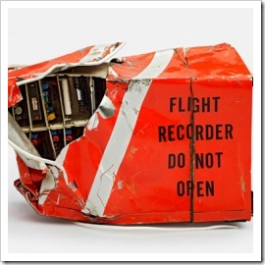
As the HP Active Health System (AHS) is part of your iLO4 firmware, all the collected data is stored in the 1GB partition of NAND flash embedded on the system board. AHS collects data from different sources including your Server ROM, NIC, Smart Array controller and optional OS related agents. As per HP documentation, AHS collects almost 1600 data items. This is huge number!!
Whenever you experience an issue with Gen8 Server, I would recommend you to share AHS log with HP support personnel. This will really help the HP support team to identify the exact issue and will help you get quicker solution. Note that Active Health System does not collect any sensitive information from your server, so it is safe to provide AHS log to HP support personnel. HP values your privacy and for more information about HP Privacy policy, you may check this link.

How to collect AHS log:
In this article, I will explain how to collect HP Active Health System (AHS) log from your HP Gen8 Server using a Command-line tool called as Active Health System Log Download CLI (AHS download CLI). This command line utility will allow you to download AHS log of your Gen8 server. This utility is available for both Windows and Linux operating System
For HP AHS download CLI to work, HP ProLiant Integrated Lights-Out Management Interface Driver must be is installed on the server. AHS download CLI tool allows you to collect the AHS log when you do not have access to the iLO web-interface or Intelligent provisioning of your server. When you run the Active Health System download command line tool on your server, it will create an .ahs package file on your Server. You need this file to HP support team for further analysis.
Here, I will discuss in detail about the three topics provided below.
- How to download and extract Active Health System Log Download CLI.
- How to download AHS log of last seven days.
- How to download AHS log between two date ranges using command line.
Let’s begin now

Download and extract AHS Log Download CLI for Windows.
Active Health System Log Download CLI for Windows is available for download at HP.com. Here, we will be discussing how to download and install this tool on your server.
1. Open www.hp.com, and click on Support & Drivers link.
2. Search using HP Server Model number (Example: DL380p Gen8).
3. Go to Driver Download page of your Server and choose the Operating System.
4. Find Active Health System Log Download CLI for Windows download link as shown below.
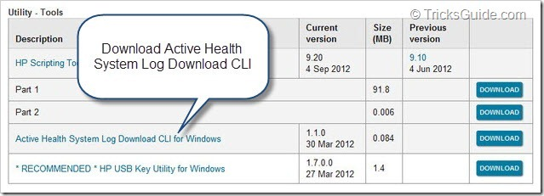

5. Download Active Health System Log Download CLI for Windows on your Server.
6. The file name is: AHSdownload_Windows_x.x.x.x.zip and it is a .ZIP file.
7. Open the ZIP file and extract it to a folder (I used WinZip program to extract .ZIP file).
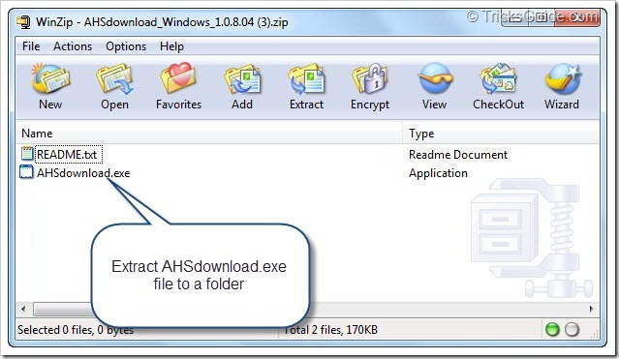
8. In my case, I extracted files to the C:\AHS folder (Save the file in any folder of your choice).
9. Open the folder in which you extracted the file. You will find AHSdownload.exe file listed there.
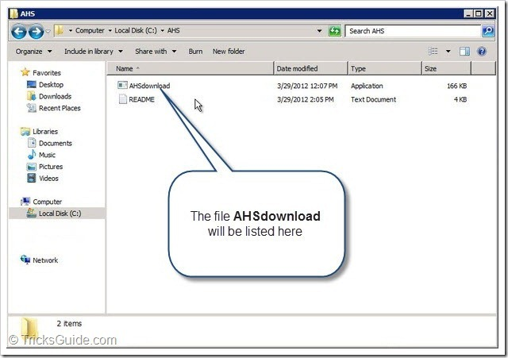
10. AHSdownload.exe is the command line tool which is used to collect AHS log.
11. Good Job, Proceed to next step now!

How to download AHS log of last seven days:
If you need to collect last 7 days AHS log from your HP Gen8 Server, then the procedure you need to follow is very easy. You just need to double click AHSdownload.exe file and it will download past 7 days AHS log from your Server. This command-line tool does not require any kind of user name or password to download the AHS log. Please check below provided steps to understand better.
1. Double click on AHSdownload.exe file (I have it saved in C:\AHS folder)
2. It will open Command prompt window and will automatically start Downloading AHS log.
3. AHS log will be saved in the same folder where AHSdownload.exe is located (Eg:- C:\AHS folder).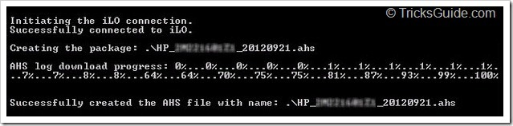

Note: By default AHSdownload.exe collects last 7 days logs.

How to download AHS log between two date ranges:
If you would like to collect logs between two date ranges, then you need to open Command Prompt on your Server and run the AHSdownload file. I hope you have basic understanding of Microsoft Command Prompt. Please refer below provided procedure to learn how to use Active Health System Log Download CLI on your Server.
1. Open Command prompt by Clicking Start, Click Run, type CMD and press Enter key.
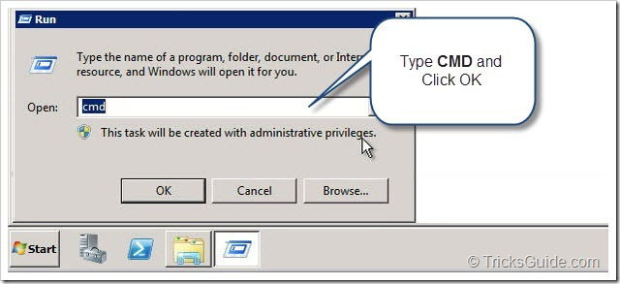
2. It will open Command Prompt window as shown below.
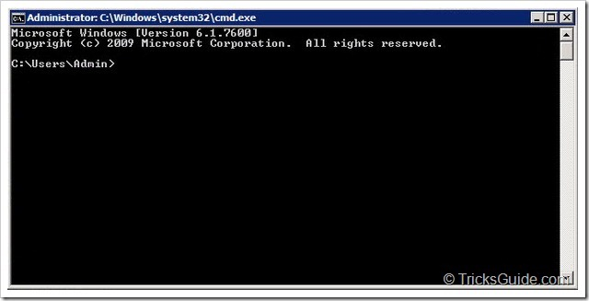
3. As the AHSdownload.exe is saved in C:\AHS folder, first you need to come back to root of C: drive.
4. Execute the command “CD\” to go to the highest level, I mean the root of the drive.
5. Then run the command “CD AHS” to change directory to C:\AHS
6. Now the Command-Prompt window will look similar to the screenshot provided below.
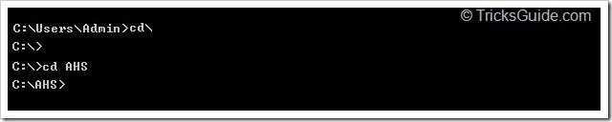
7. You may collect AHS log between two date ranges now. The syntax of command is provided below.
8. For easy understanding, please check below said example.
9. It will download the AHS log from 22nd-September 2012 to 23rd-September-2012.
10. If you need further clarification, please check below provided screenshot.
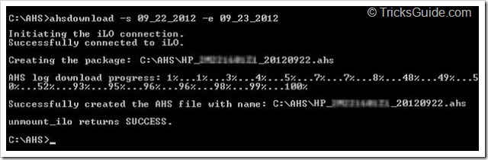
11. AHS log will be saved in the same folder where AHSdownload.exe is located (Eg:- C:\AHS folder).

Note: If you wish to save AHS log in a specific folder then you need to use [-d] switch.

12. To save AHS log to a specified folder, follow the command syntax provided below.
13. For better understanding, please check below provided example.
14. This command will save the AHS log from 22nd-Sept to 23rd-September to C:\Windows folder.
15. If you wish to see the command-prompt screen, please check below provided screenshot.
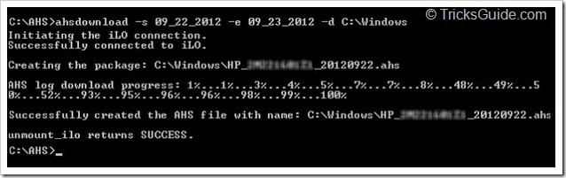

Note: If you wish to save complete AHS log of your server, then you need to use [-a] switch. In most cases, Downloading complete AHS log will not be necessary. Remember that this process may take long time to complete.

16. To save the complete AHS log file of your Gen8 server, please run below provided command.
17. Above said command will download all the data from the AHS log. Wait till it finishes.
18. For better understanding, please check below provided screenshot.
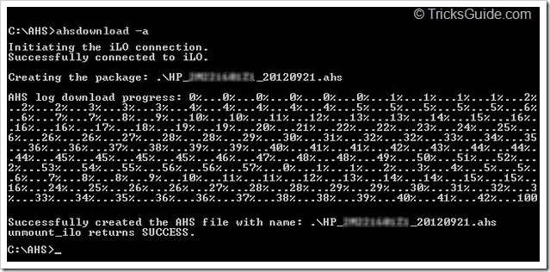
19. Congrats, you did it!!


AHS report can also be collected through the HP Intelligent Provisioning interface or by using iLO4 web-interface. I will be writing another article regarding this. Thank you for reading my blog, leave your comments and keep rocking
- See more at: http://www.tricksguide.com/download-ahs-log-hp-gen8-server-active-health-system-log-cli.html#sthash.BOdulFAG.dpuf

